MEHRAN UNIVERSITY

OF ENGINEERING & TECHNOLOGY

JAMSHORO, PAKISTAN

To learn various CMD network commands

Subject: COMPUTER NETWORKS (PR)

(Lab 4 - Tasks Solution)

|  |  |
| --- | --- |
| **Roll No:** | **22SW028** |
| **Section:** | **I** |

**LAB TASKS:**

**TASK1.**

**Execute the above mentioned commands and display the outputs.**

**Ans:**

**1. ipconfig**:

Tells the IP Address of the system you run this command on, and some other details as well.

**2. ping:**

**3. tracert**: 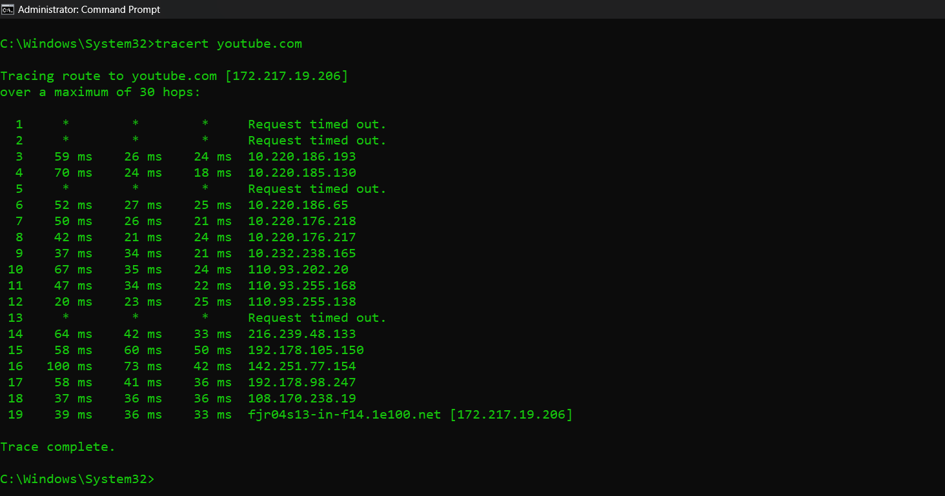

**4. net view:**

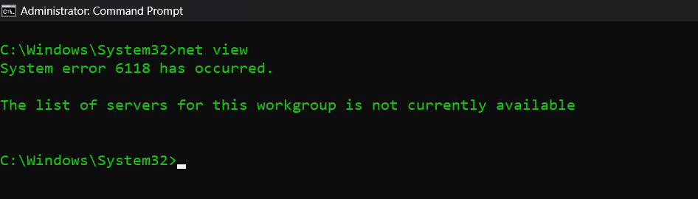

**TASK2.**

**Find and explain a network command that changes the ipaddress of your computer from your command prompt. Change the ipaddress and display the output.**

Ans: The network command to change the Ip address is netsh.

First we have to know our adapter’s interface name. We can do this by using “**netsh interface ipv4 show interfaces**” command.

Then we can run this command:

**netsh interface ipv4 set address name="Wi-Fi" static 192.168.1.10 255.255.255.0 192.168.1.1**

to change the ip address. After changing, we can run **ipconfig** command to check the change.